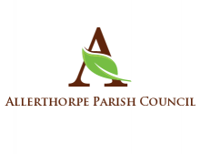
Annual Parish Meeting
14th June 2023 at 7pm
in Allerthorpe Village Hall

This is an open meeting to which everyone is invited.
The Parish Council will be interested to hear your views on parish matters.
If you have a particular query, then please give a few days advance notice so that information can be gathered if necessary. This can be done by emailing the clerk.

Jane Smith
Parish Clerk
clerk.allerthorpe_pc@btinternet.com

Annual Parish Meeting
14th June 2023 at 7pm
in Allerthorpe Village Hall

This is an open meeting to which everyone is invited.
The Parish Council will be interested to hear your views on parish matters.
If you have a particular query, then please give a few days advance notice so that information can be gathered if necessary. This can be done by emailing the clerk.

Jane Smith
Parish Clerk
clerk.allerthorpe_pc@btinternet.com

